How Yoga and Other Healthy Habits Can Help You Overcome Grief
In the midst of grief, it can be difficult to focus on your health. However, it’s important not to neglect yourself while going through this challenging time in your life. The good news is that you can take small steps toward healing by making sure you maintain certain healthy habits.
These habits are good for grieving at any time, but they might offer even more comfort in a difficult time. Start with one goal and gradually add others if you find it difficult to focus on more than one in the beginning.

Healthy Habits for Healthy Living
It can be difficult to heal from a major life event. And it can be equally hard to know where to start or what to do for the best. The most important thing you can do when beginning your healing process is to create healthy goals.
Remember, the grieving process is a long and difficult journey. It’s even more challenging if you don’t have the support of friends or family. Finding ways to stay healthy, or at least stay active, can be a good way to start healing in your own way.

Healthy Exercise and Yoga
Exercise is one of the easiest ways to stay healthy while grieving. By exercising on a regular basis, it will relieve stress and release endorphins that will make you feel better.
But exercise doesn’t have to be all about physical activity; it can include activities like meditation or yoga. Yoga is a great way to let go of stress and restore calmness to your body. Try practicing yoga at home or in a studio near you.
These calming activities could help you heal from your loss in a healthy way as well as provide comfort during a difficult time.

Learn to Identify Stress Triggers
When you know what causes stress and sadness in your life, you can take a proactive approach to eliminate those triggers. And when you do that, you will find your stress melting away. It’s all about proper management, but it begins with knowing what to watch out for.

Find Comfort in Peaceful Surroundings
When someone you love dies, and you’re grieving, one of the most important things is to find ways to comfort yourself.
One way is by making your home environment more peaceful. Remember that we spend a lot of time in our homes, so it’s important to make sure it’s somewhere that you can recover and heal.
There are many things you can do to create a peaceful home environment, but here are some of the most popular ones:

Declutter: Clutter can be extremely stressful. If your home is cluttered and there’s stuff piled up everywhere, then this is just adding to your stress level. There’s nothing worse than buying a new couch only for the living room to be too cluttered for the couch to fit in it.
Rearrange Closets and Cabinets: When our closets and cabinets aren’t organized, it can feel like everything is falling apart or out of control. Therefore, it might help to rearrange your closets or cabinets so there are clear paths for foot traffic and so things are more organized when you need them. It’s a great way to reduce stress.
Create a Serene Meditation Space: Having an area where you can meditate comfortably might bring peace into your home environment, as well as peace within yourself just by being able to sit down in one place every day and take some time to heal.
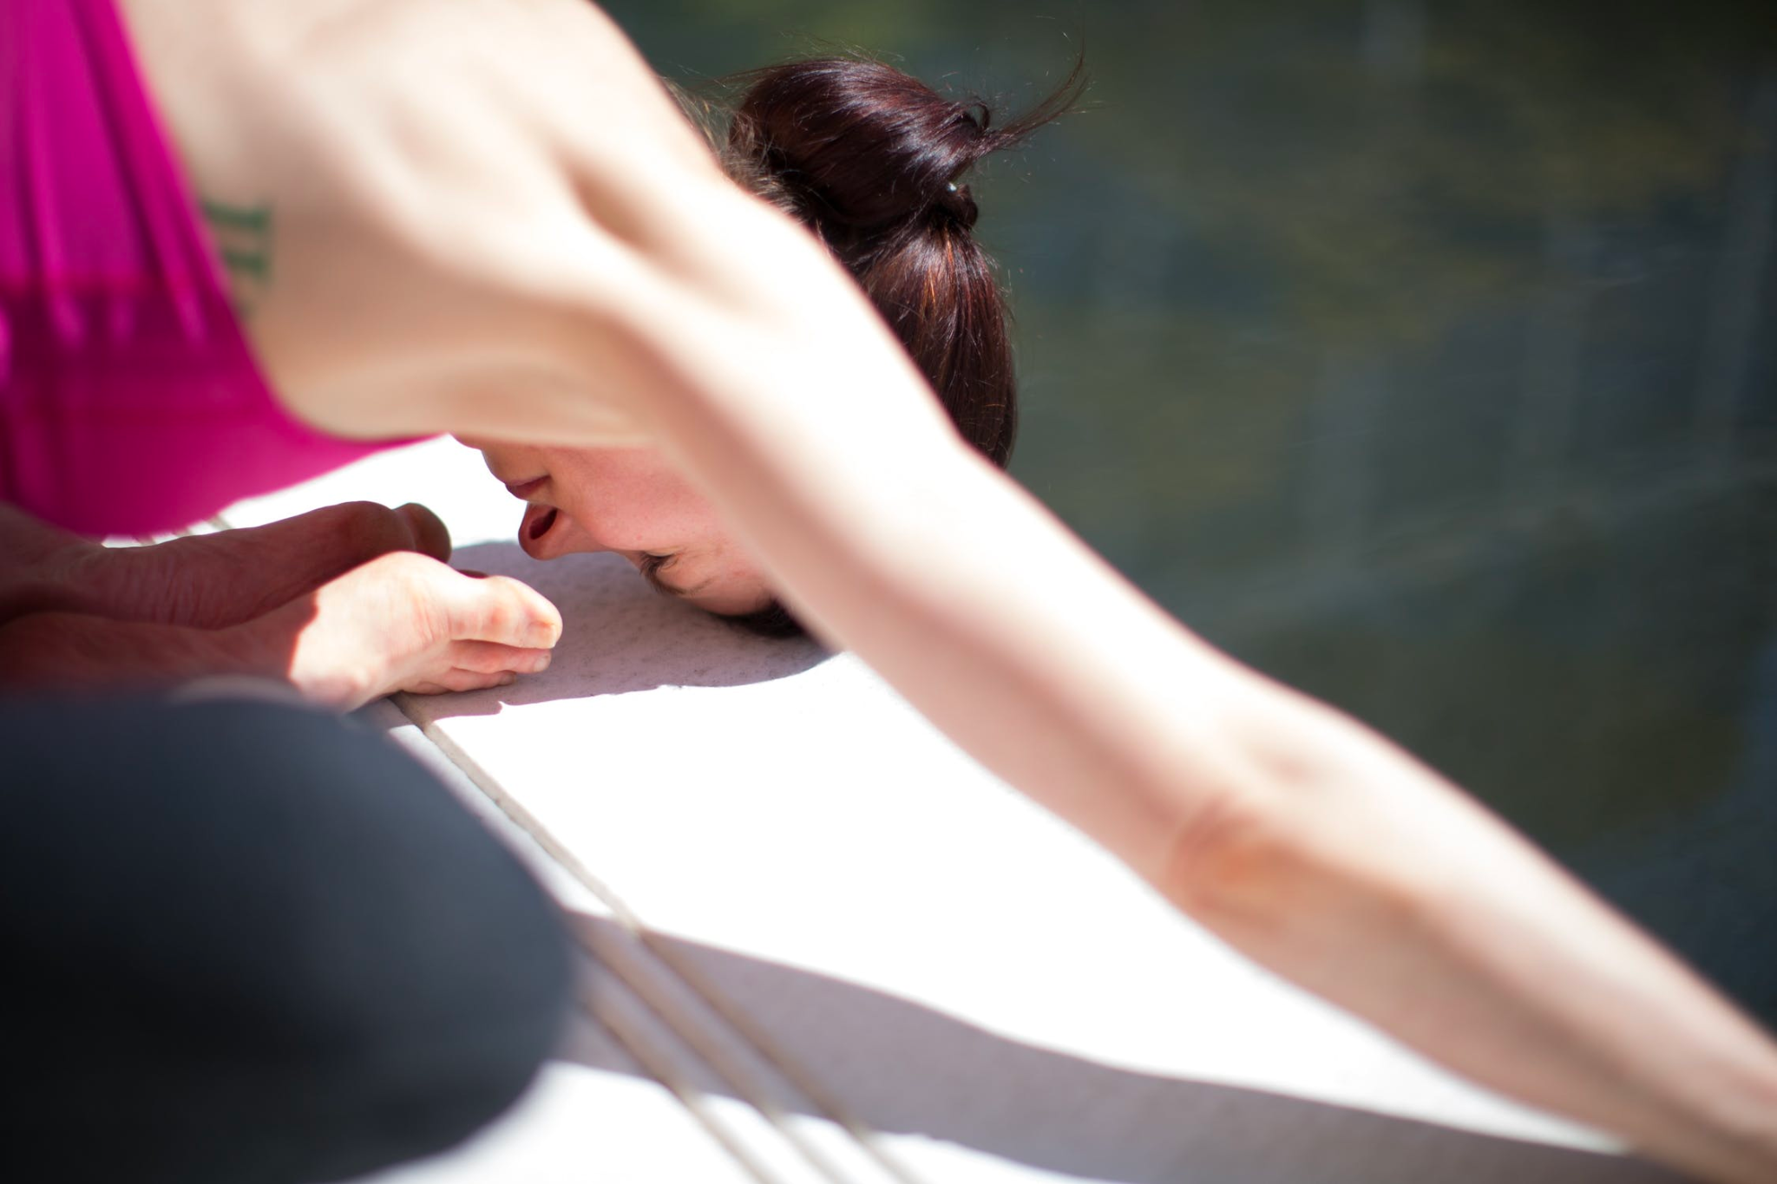
Image via Pexels

